**Mackie Facilities Masterplan Projects:**

**Project 1:**

**Clubrooms:**

2 storey facility, glass-fronted fold-up windows upstairs, with balcony & Lift going to upstairs.

Air-conditioning, Wifi, Loud-speakers / intercom.

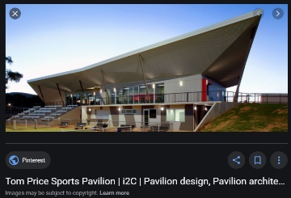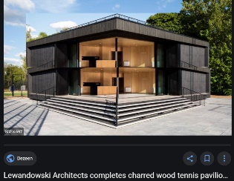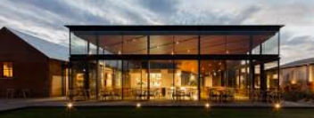

**Downstairs**

4 changerooms: 2 x males & 2 by female friendly changerooms, and separate Umps room. Roller doors separating each so they can be opened up. Toilets & showers in each changeroom (gives capacity to operate male & female games at the same time)

Indoor net/training facility (see below).

Gym room

First Aid room

Permanent storage rooms for cricket, etc.

Meeting room

Canteen & Kitchen for café-style catering, with veranda public dining.

Outside paved ground, with seating area – benches & tables – for members & public to sit, eat, and watch cricket.

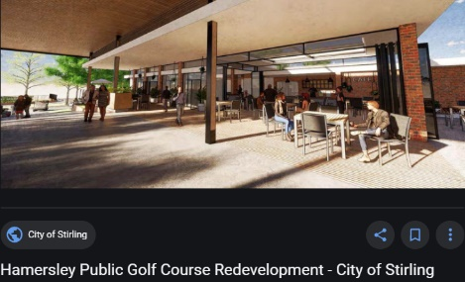

Outside Male/Female & disabled toilets

**Upstairs**

Large function room with opening to the balcony for all community to use

Proper publican style bar, with beer on tap and large drink fridge to hold capacity of variety of drinks

Male & female toilets & disabled toilets

Office/small boardroom, with electronic scoring bench overlooking ground

Storage rooms

**Project 2:**

**Reserve**

One large oval & one boutique smaller oval to run 2 games at the same time.

Improve lighting so that night-time games can be played – cricket & football (soccer) – 150 lux.

**Project 3:**

**Indoor Nets**

Six nets to be located inside, fifty metres long & twenty metres wide, with lighting, internal framework, and cloth netting inside.

Nets are booked by the club in normal training/playing hours but can be leased out by the council to external parties at other times.

Nets to be repositioned to a North/South alignment.

* Note, Glen Eira has no such facility. We book indoor nets outside of Glen Eira to meet this purpose.

